EXPT. NO: 11 | FUNCTIONS
DATE:5.2.2021 | FUNCTIONS
Aim:
To write a C program for the following to
- design a calculator
- Sort the list of numbers
1. Design a calculator
Algorithm
- Start the program
- PRINT Enter an operator (+, -, *,):
- GET cla
- PRINT Enter The Number 1 and 2:
- GET a and b
- SWITCH cla
- CASE '+'
- r = add(a, b)
- BREAK
- CASE '-':
- COMPUTE r = sub(a, b)
- BREAK
- CASE '*':
- COMPUTE r = multi(a, b)
- BREAK
- CASE '/':
- COMPUTE r = div(a, b)
- BREAK
- DEFAULT
- PRINT You Have Enter Wrong operator
- Stop the program
Program
#include<stdio.h>
int main() {
char cla;
int a, b, r;
printf("Enter an operator (+, -, *,): ");
scanf("%c", &cla);
printf("Enter The Number 1 and 2: ");
scanf("%d %d", &a, &b);
switch(cla) {
case '+':
r = add(a, b);
break;
case '-':
r = sub(a, b);
break;
case '*':
r = multi(a, b);
break;
case '/':
r = div(a, b);
break;
default:
printf("You Have Enter Wrong operator");
}
if(r) {
printf("%d %c %d = %d", a, cla, b, r);
}
return 0;
}
int add(int a, int b) {
return a + b;
}
int sub(int a, int b) {
return a + b;
}
int multi(int a, int b) {
return a + b;
}
int div(int a, int b) {
return a + b;
}
Output
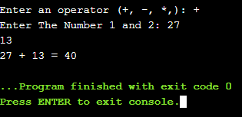
2. Sort the list of numbers
Algorithm
- Start the program
- PRINT Enter the value of N:
- GET n
- PRINT Enter the numbers:
- FOR i = 0; i < n; i++, then go to step 5 or other wise go to step 6
- GET number[i]
- CALL sort FUNCTION

- sort FUNCTION START
- FOR i = 0; i < n; i++, then go to step 3 or other wise go to step 8
- FOR j = i + 1; j < n; j++, then go to step 4 or other wise go to step 8
- IF number[i] > number[j]
- ASSIGN temp = number[i]
- ASSIGN number[i] = number[j]
- ASSIGN number[j] = temp;
- PRINT The numbers arranged in ascending order are given below:
- FOR i = 0; i < n; i++, then go to step 15 or other wise go to step 10
- PRINT number[i]
Flowchart
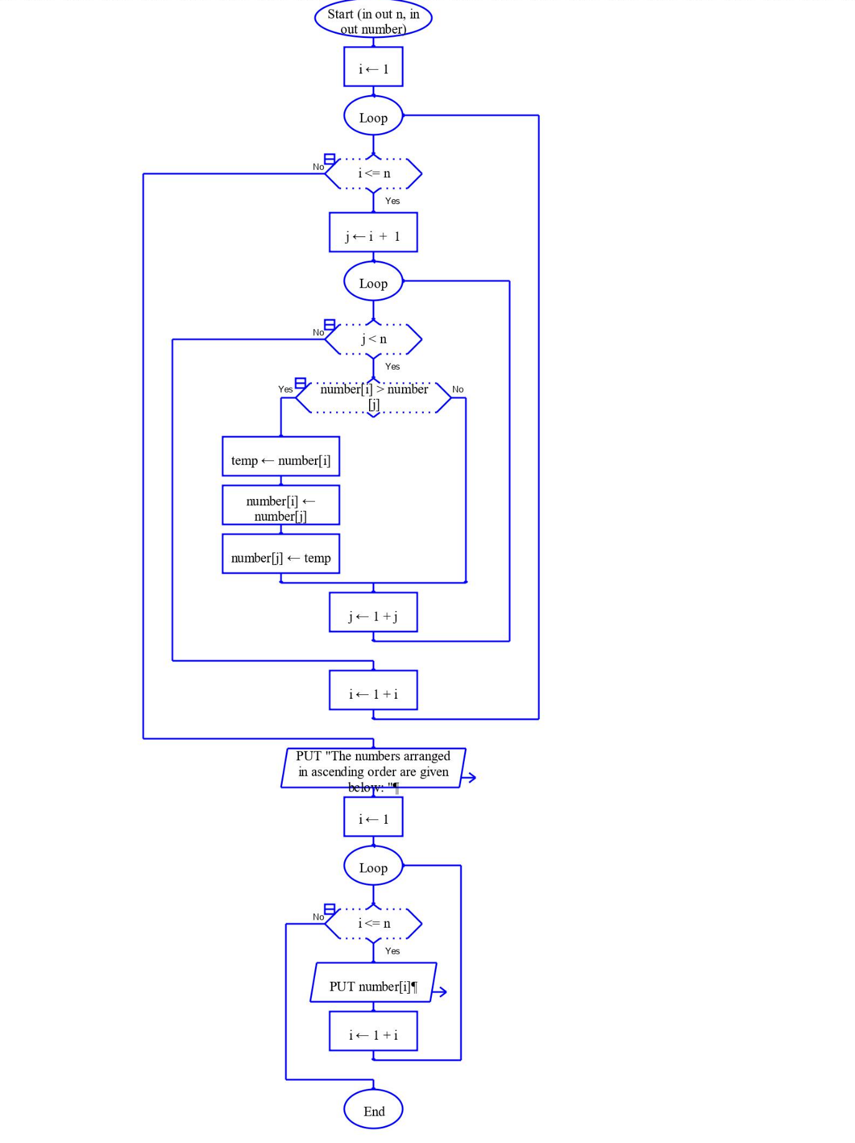
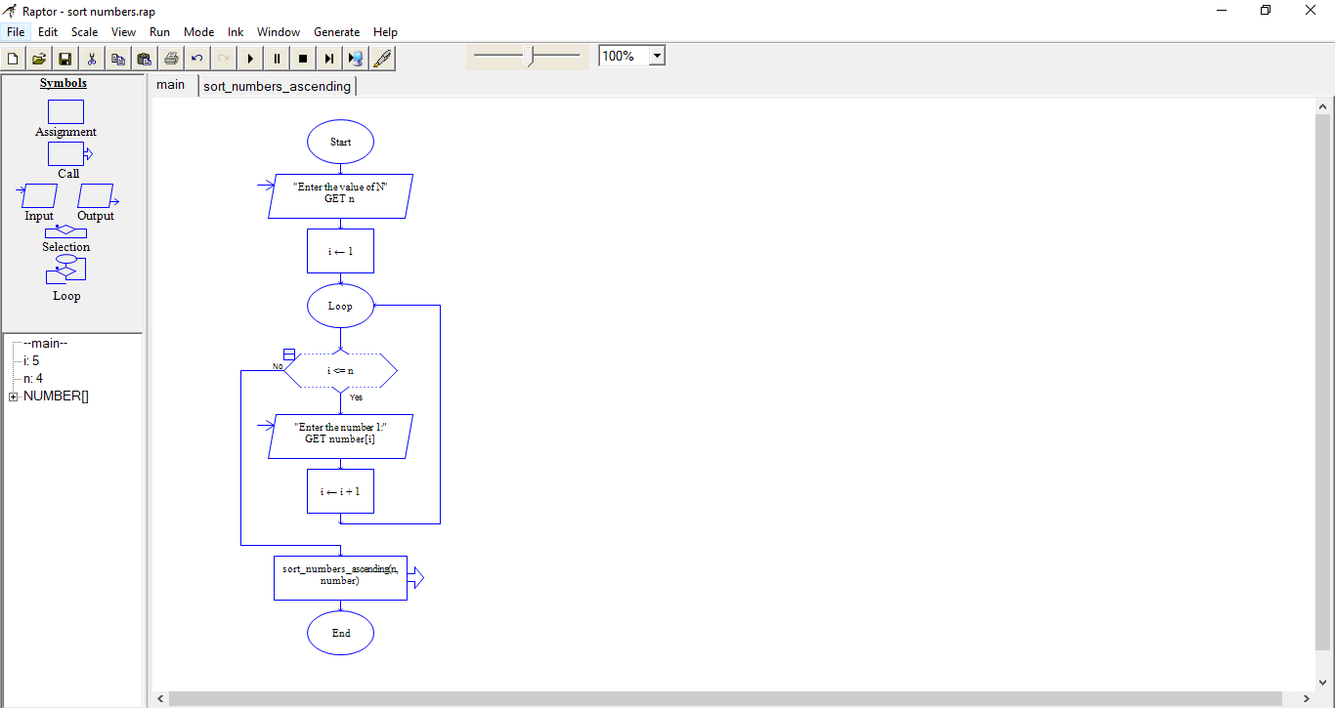
Program
#include <stdio.h>
int main() {
int i, j, temp, n, number[30];
printf("Enter the value of N: \n");
scanf("%d", &n);

printf("Enter the numbers: \n");
for (i = 0; i < n; ++i)
scanf("%d", &number[i]);
sort_numbers_ascending(n, number);
return 0;
}
int sort_numbers_ascending(int n, int number[]) {
int temp, i, j;
for (i = 0; i <= n; ++i) {
for (j = i + 1; j < n; ++j) {

if (number[i] > number[j]) {
temp = number[i];
number[i] = number[j];
number[j] = temp;
}
}
}
printf("The numbers arranged in ascending order are given below: \n");
for (i = 0; i < n; ++i)
printf("%d\n", number[i]);
}
Output
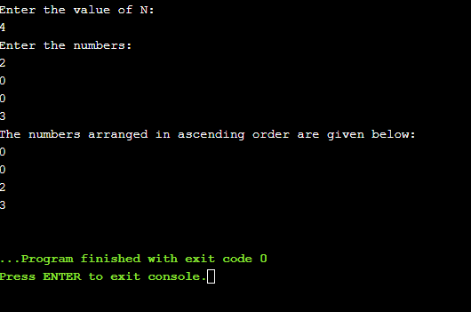
Result
Thus the C program was written and executed successfully for the following
- design a calculator
- Sort the list of numbers

